Basic Shell Scripts:
#!/bin/bash
# Simple output script
echo "Hello World"

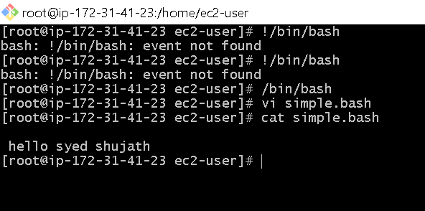

2 Defining Tasks ?

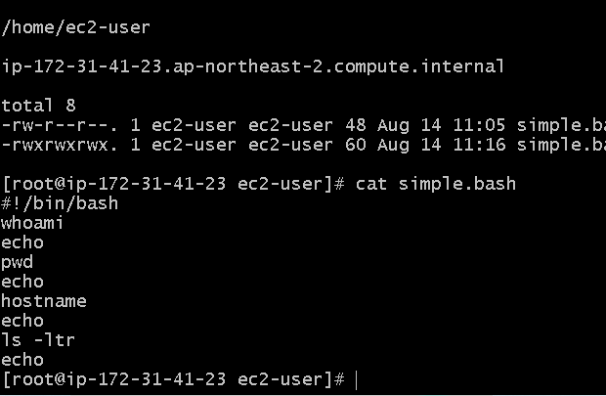
- Who ami
- echo
- pwd
- echo
- hostname
- echo
- ls -ltr
- echo

3. Defining variables ?
#!/bin/bash
# Example of defining variables
a=Imran
b=Afzal
c=’Linux class’
echo "My first name is $a"
echo "My surname is $b"
echo ‘My surname is $c
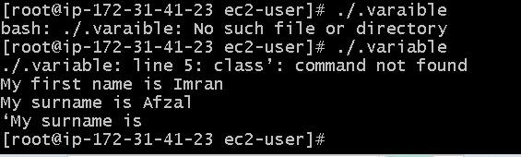

4) Read Input ?
- Ans) #!/bin/bash
- # Read user input
- echo "What is your first name?"
- read a
- echo
- echo "What is your last name?"
- read b
- echo
- echo Hello $a $b

- 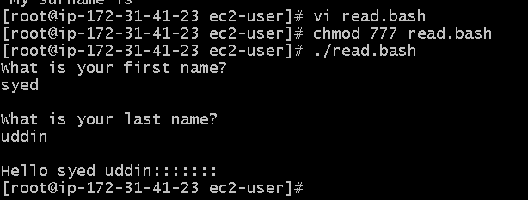
5) Scripts to run commands within
- Ans #!/bin/bash
- # Script to run commands within
- clear
- echo "Hello `whoami`"
- echo
- echo "Today is `date`"
- echo
- echo "Number of user login: `who | wc -l `"
- Echo
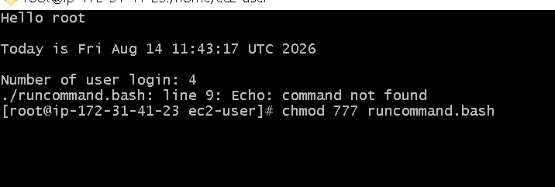

06) Read input and perform a task ?
- #!/bin/bash
- # This script will rename a file
- echo Enter the file name to be renamed
- read oldfilename
- echo Enter the new file name
- read newfilename
- mv $oldfilename $newfilename
- echo The file has been renamed as $newfilename
